WELCOME
TO OUR CHURCH
SOCIAL

DINNER


- Turkey
- Southwestern Chili
- Ranch Style Beans
- Mouth-Watering
Mashed Potatoes,
Corn & Gravy
- Corn Bread

Dessert
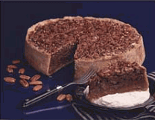

- Chocolate Fudge

Cake
- Strawberry Cheesecake
- Carrot Cake &
Cream Cheese
frosting

ACTIVITIES

5:00 p.m.
Dinner

6:00 p.m.
Childrens Musical concert

7:00 p.m.
Volley Ball,
Bocci Ball,
& Horse Shoes!

ANNOUNCEMENT

Janice & Mark Bellamy had
their baby boy, Andrew Mark, on 8/5/00. 7lb 3oz

