Welcome to

NELSON’S

ICE CREAM

PARLOR
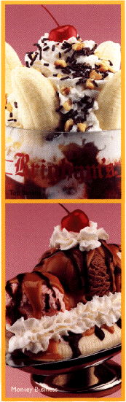

TRY OUR SPECIAL OF THE MONTH

DELICIOUS BANANA SPLIT

Sliced bananas with a scoop of vanilla, chocolate, and strawberry topped with caramel, fudge, whip crème, and a cherry.

BUY ONE
GET ONE FREE

Only $4.95!

Enjoy one of our delicious Shakes!
Over 50 flavors to choose from.


One Flavor
$2.95

Two Flavors
$3.49

Cherry-Lime
Grape Grapefruit
Grape-Lime Honey Apple Lemon Lemon Lemon-Lime Lime

Mango
Orange Amaretto Peach Cantaloupe
Cantaloupe Ice
Cranberry
Egg Nog
Fresh Peach
Peach Ice
Pumpkin
Pumpkin Pie
Watermelon Ice
Raspberry
Spiced Apple
Strawberry
Tropical

B-52
Banana Cream

Banana Nut
Banana Nut Bread
Belgian Oreo
Belgian Toffee
Blackberry
Black Velvet
Blueberry
Blueberry Crunch
Boston Cream Pie
Chocolate Walnut
Brandy Alexander
Brandy Biscotti
Butter Almond
Pecan
Butterfinger
Cappuccino
Caramel
Cheesecake
Peanut Butter
Cookie Dough
Chocolate Grand



ICE CREAM CONES

1 SCOOP $2.50
2 SCOOPS $2.95

3 SCOOPS $3.49

Sugar Cone add $.50

Almond
Anise
Apricot
Banana
Banana Mocha
Banana Rum
Blueberry
Buttermilk
Butter Pecan
Butterscotch
Cantaloupe
Cherry
Cherry & Chocolate
Chocolate & Banana
Chocolate
Chocolate Mint
Cinnamon
Coconut
Coffee
Cookie Dough
Fudge Chunk
Fudge

German Chocolate
Grape Nuts
Green Tea
Hazelnut

Lemon
Lemon
Buttermilk
Lemon & Vanilla
Mango
Maple Walnut
Mint
Orange
Peach
Peanut Butter
Pear
Pistachio
Pumpkin
Raspberry
Rocky Road
Strawberry
Straw-banana
Vanilla
Vanilla chip
Vanilla Crunch

