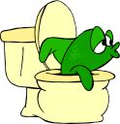

WHEN YOU TINKLE

PLEASE DON’T SPRINKLE
STUDENT

JOSH COLT

READING ASSIGNMENT

GREEN EGGS & HAM__________
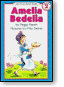

AMELIA BEDELIA _____________________

ONE FISH TWO FISH RED FISH BLUE FISH ___________

IF YOU GIVE A PIG A PANCAKE ________
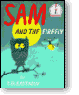
SAM AND THE FIREFLY ____________

WHERE DO BALLOONS GO? ____________

THE FOOT BOOK ______________

CHICKA CHICKA BOOM BOOM ________

I WILL NEVER (NOT EVER) EAT A TOMATOE ____________

MADELINE ____________

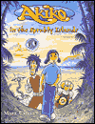
AKIKO IN THE SPRUBLY ISLANDS __________

CAROLINA AUTUMN _________

WHERE THE WILD THINGS ARE ________
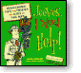
JEEVES, I NEED HELP! ________

THE KID WHO RAN FOR PRESIDENT __________

PLEASE

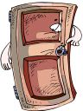
DO NOT DISTURB

