
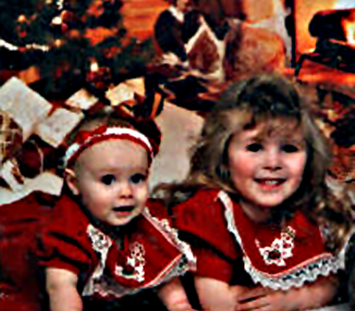
SENDING YOU BEST WISHES FOR A MERRY CHRISTMAS
AND A HAPPY
NEW YEAR!

HAPPY HOLIDAYS FROM
JEREMY, SAMANTHA,
ASHLEY, AND MCKENNA LARSEN
THE FIRST CHRISTMAS

The angels hung the stars that night In Bethlehem, overhead, And one was new, and strangely right Above His manger Bed.

'Twas the first Yule decoration,
Yet so, o'er all the earth, Now those of every nation Commemorate His Birth.

Great kings arrived from far-off lands Bearing their gifts of joy, And shepherds brought their choicest lambs To The Master's Little Boy.

This the first gift giving was,
And through the still night rang. The first sweet Christmas carols as The white robed angels sang.

Ah, sweet were the songs from Heaven, And fair was the star's pure light, And the richest gift e'er given God gave to the world that Night.

