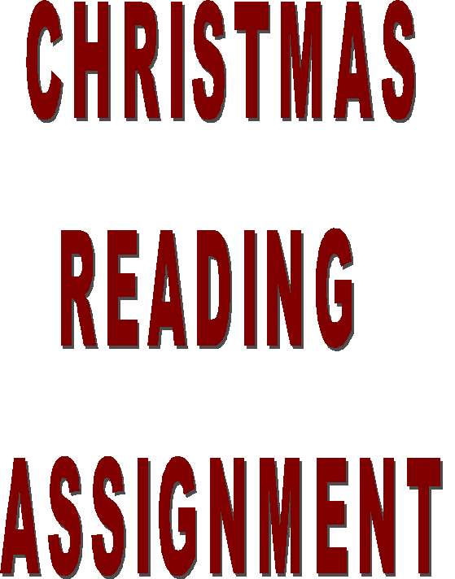

TWAS THE NIGHT
BEFORE CHRISTMAS

'Twas the night before Christmas, when all through the house Not a creature was stirring, not even a mouse; The stockings were hung by the chimney with care, In hopes that St. Nicholas soon would be there;
The children were nestled all snug in their beds, While visions of sugar-plums danced in their heads; And mamma in her 'kerchief, and I in my cap, Had just settled down for a long winter's nap,
When out on the lawn there arose such a clatter, I sprang from the bed to see what was the matter. Away to the window I flew like a flash, Tore open the shutters and threw up the sash.

The moon on the breast of the new-fallen snow gave the lustre of mid-day to objects below, When, what to my wondering eyes should appear, But a miniature sleigh, and eight tiny reindeer, With a little old driver, so lively and quick, I knew in a moment it must be St. Nick. More rapid than eagles his coursers they came, And he whistled, and shouted, and called them by name;

"Now, DASHER! now, DANCER! now, PRANCER and VIXEN! On, COMET! on CUPID! on, DONDER and BLITZEN! To the top of the porch! to the top of the wall! Now dash away! dash away! dash away all!"
As dry leaves that before the wild hurricane fly, When they meet with an obstacle, mount to the sky, So up to the house-top the coursers they flew, With the sleigh full of toys, and St. Nicholas too.

And then, in a twinkling, I heard on the roof The prancing and pawing of each little hoof. As I drew in my hand, and was turning around, Down the chimney St. Nicholas came with a bound.
He was dressed all in fur, from his head to his foot, And his clothes were all tarnished with ashes and soot; A bundle of toys he had flung on his back, And he looked like a peddler just opening his pack.
His eyes -- how they twinkled! His dimples how merry! His cheeks were like roses, his nose like a cherry! His droll little mouth was drawn up like a bow, And the beard of his chin was as white as the snow;
The stump of a pipe he held tight in his teeth,
And the smoke it encircled his head like a wreath;
He had a broad face and a little round belly,
That shook, when he laughed like a bowlful of jelly.

He was chubby and plump, a right jolly old elf, And I laughed when I saw him, in spite of myself; A wink of his eye and a twist of his head, Soon gave me to know I had nothing to dread;
He spoke not a word, but went straight to his work, And filled all the stockings; then turned with a jerk, And laying his finger aside of his nose, And giving a nod, up the chimney he rose;
He sprang to his sleigh, to his team gave a whistle, And away they all flew like the down of a thistle. But I heard him exclaim, ere he drove out of sight,

"MERRY CHRISTMAS TO ALL,
AND TO ALL A GOOD-NIGHT!"

THE FIRST CHRISTMAS

The angels hung the stars that night In Bethlehem, overhead, And one was new, and strangely right Above His manger Bed.

'Twas the first Yule decoration,
Yet so, o'er all the earth, Now those of every nation Commemorate His Birth.

Great kings arrived from far-off lands Bearing their gifts of joy, And shepherds brought their choicest lambs To The Master's Little Boy.

This the first gift giving was,
And through the still night rang. The first sweet Christmas carols as The white robed angels sang.

Ah, sweet were the songs from Heaven, And fair was the star's pure light, And the richest gift e'er given God gave to the world that Night.

