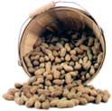

PEANUT PANTRY
PUNCH CARD
Buy 10 BAGS OF NUTS
GET ONE FREE
1
2
4
7
3
5
6
8
9
10
FREE
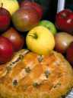
STATE COUNTY FAIR
Presents the:
BEST TASTING
APPLE PIE AWARD
To:

Stephanie Miller

Executive Taste Tester
Date


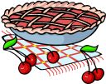
CHURCH PICNIC

Presents the

“FASTEST CHERRY PIE

EATING AWARD”
TO BRAD MECHAM

PASTOR

Date

