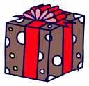
HAPPY

BIRTHDAY

JEFF

From Michelle

GRADUATION
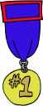

TYSON
We are so proud of you!
Love Mom & Dad
Happy 15th
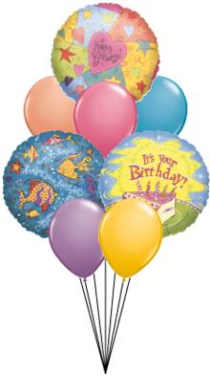
Birthday

Sarah

From your

Best Friend Ashley


Place setting

for

JOHN

GRADUATION DINNER

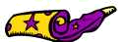
MICHAEL’S
SURPRIZE

BIRTHDAY

PARTY

SEAT FOR MARCIE

WAY TO GO KENDRA
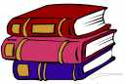
SUMMER READING
AWARD
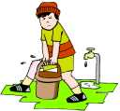
ADAM WINS
THE
CLEANEST
ROOM IN
THE HOUSE
AWARD
HUG COUPON
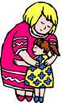
FOR MOM
VALID FOR
5 HUGS
__ __ __ __ __

KISS COUPON
FOR DAD
GOOD FOR
5 KISSES
___ ___ ___ ___ ___
CONGRATULATIONS

TOM
FAMILY
HONESTY
AWARD

