RIVERSIDE ELEMENTARY SCHOOL

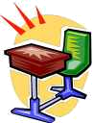
Hal Einstein, Principal
555 South Riverside Dr.
San Diego, CA 95866-4545
www.riversideelem.edu
heinstein@riverside.edu
540- 652-6521, Fax: 540-652-6572


SCHOOL ORGANIZATION

AWARD
CEREMONY DINNER

TABLE RESERVED
FOR STUDENT
KYLE SMITH & FAMILY

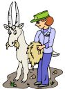
PARENT REMINDER
ZIONS ZOO FIELD TRIP IS ON THURSDAY, MAY 10TH. ALL PERMISSION SLIPS MUST BE TURNED IN BY SEPTEMBER 5TH.



ANNOUNCEMENT
MANDATORY
STAFF MEETING ON
FRIDAY, JANUARY 12TH
AT 3:00 P.M. IN THE
AUDITORIUM!

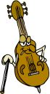

SCHOOL NEW YEARS MUSICAL CONCERT

TUESDAY, JANUARY 9th
AT 6:00 P.M. IN THE AUDITORIUM.


HILLTOP MIDDLE

SCHOOL

RECOGNIZES
CAMRY WILDE

FOR HAVING
PERFECT ATTENDENCE

JOHNSTON ELEMENTARY SCHOOL
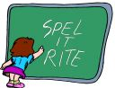

SPRING 2000

SPELLING “B”

WINNER IS
JOSEPH CARTWRITE

TEACHER _________________ DATE __________

COPPER CREEK HIGH SCHOOL
Mrs. Stansbury, English Teacher
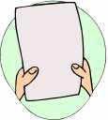
555 North Copper Rd.
Boise, ID 85647-5656
617-998-5959, Fax: 617-998-5960
jstansbury@ccreek.edu

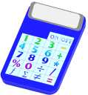

MICHAEL

CONGRATULATIONS

ON GETTING

AN “A” in Math!

YOU HAVE MADE GREAT IMPROVEMENTS. I AM VERY PROUD OF YOU. ENJOY YOUR GIFT! FROM: MS. HAGGELL

Mr. Hammel’s 2nd Grade Class
JOHN ANDREWS
is the
STAR STUDENT OF THE MONTH
for the month of
January 2000

