
Friends Are

Like Angels

Our friends are like
angels, Who brighten
our days. In all kinds
of wonderful, Magical
ways.

Their thoughtfulness
comes, As a gift from above. And we feel
we're surrounded, By
warm, caring love.

Like upside-down
rainbows, Their smiles
bring the sun. And they
fill ho-hum moments,
With laughter and fun.

Friends are like angels,
Without any wings.
Blessing our lives,
With the most precious things.

This angel, Was
sent to watch
over you.
SCHOOL
ENGLISH READING
ASSIGNMENT



January 5th

Chapter 1

Chapter 2

January 19th
Chapter 4

Chapter 5

February 2nd

Chapter 6
Chapter 7

February 16th
Chapter 8

Chapter 9

GODS BOXES
OF LOVE

I have in my hands two boxes Which God gave me to hold He said,"Put all your sorrows in the black, And all your
joys in the gold."

I heeded his words, and in the two boxes Both my joys and sorrows I store But though the gold became heavier each day.

The black was as light as before With curiosity, I opened the black I wanted to find out why And I saw, in the base of the box, a hole which my sorrows had fallen out by.

I showed the hole to God,
and mused aloud, "I wonder where my sorrows could be." He smiled a gentle smile at me. "My child, they're all here with me." I asked,
"God, why give me the boxes, "Why the gold, and the black with the hole?"

"My child, the gold is for you to count your blessings, the black is for you to let go."


SULIVAN BOOKS
www.sulivanbooks.com
4589 West. Saddleback Rd.

Virginia Beach, VA 95857
757-852-6523

Thanks for visiting us.

When you come back please bring this bookmark with you to receive 10% off of your next purchase!

Offer Expires 6/1/01



NELSON’S

ICE CREAM PARLOR
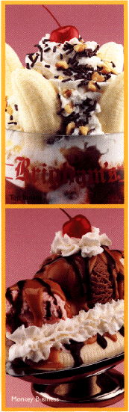

GRAND
OPENING
CELEBRATION!

Come celebrate the Grand Opening of Nelson’s Ice Cream
Parlor on
February 15th!

Bring this coupon to receive 50% off any item!

Offer Expires
February 25, 2001

